Product Requirements: Meta New Pricing 2026
Product Manager : Elsa Vinietta
Engineering Manager : Rizky Nuredja
Stakeholders : Mochamad Taufiq HidayahSabila Nurul FauziahTommy Saputra
Launch Date (target) : Septembar, 2026
Link to PM Tool :

Version History

Version | Date Change | Changelog Summary
v0.1 | Aug 20, 2026 | Initial Document

Approval

Created by | Elsa Vinietta (PM)
Reviewed by | Lyco Adhy(HoP)
 | Mochamad Taufiq Hidayah(Requestor)
Acknowledge by | Rizky Nuredja(EM)
 | Irfan Septiyana Putra(Data)
 | Gaby Satria Perdana(Design)
 | Muhammad Ikhsan Firmansyah(CIS)
 | Rivo Akbar Maulana Suwasdinar(Finance)
Approved by | A. Afriadi Alamsyah(HoD Product)
 | Tommy Saputra(HoD Requestor)

Requirements

Design/Mockup/User Flow
Link Figma disini

Data Requirements
Put Tracker and Dashboard Requirements Here
Tracker document

Dashboard requirement

Dependency Mapping
Put Tracker and Dashboard Requirements Here

Security Requirements/Risks
Define any risk on this initiative, such as: Financial (business/loss), Legal (hukum/data privacy), or Technological (system/server)

Risk Type | Risk Description | Mitigation Plan | Relevant Stakeholders | Approval Status
Financial |  |  |  | Approved
Legal |  |  |  | Approved
Technological |  |  |  | Approved

No | User Story | Acceptance Criteria | Design
1 | As an Everpro biz ops admin, I want to manage paid message pricing | AC1 [Credit Management - Admin] Base price  Given I am Everpro biz ops admin  When there is price update from Meta  Then I should be able to update the most updated per message base price from Meta to database based on:  - category (Marketing, Utility, Authentication, Service) X recipient country  And I should be able to set the effective date of the new base price  AC2 [Credit Management - Admin] Mark up price for general users  Given I am Everpro biz ops admin  Then I can set markup per message price for general users based on:  - category (Marketing, Utility, Authentication, Service) X recipient country  And I should be able to set the effective date of the new mark up price  AC3 [Credit Management - Admin] Customizable pricing  Given I am Everpro biz ops admin  Then I can customize markup per message price for specific users based on user IDs based on:  - category (Marketing, Utility, Authentication, Service) X recipient country  And I should be able to set the effective date of the new custom mark up price  AC4 [Credit Management - Admin] Price logging  Given I am Everpro biz ops admin  When there is changes requested for base price, mark up price, and customizable pricing  Then I want the system to record log for the changes; including these information:  - Actor  - New price, per message category, per recipient country, per user ID  - Timestamp when the new price is valid
2 | As an Owner/Supervisor, I want the system to execute my paid message delivery with the right timing and cost | AC1 [Broadcast Management or Chatroom] Messages within “Free Entry Point” window is not billable  Given Meta “free entry point window” is active (due to inbound from CTWA or WTWA)  When there is a message sent within that timeframe  And the message is either marketing, utility, authentication, or service message  And the message is either sent via broadcast, chatroom (human/AI/bot), or API  Then the validation and deduction process will not be executed  And the message will be send immediately  AC2 [Broadcast Management or Chatroom] Credit isolation for processed message  Given I saved a broadcast campaign with specified schedule and target to send a specific template message  Or I am trying to send a template or a service message via chatroom (human/AI/bot)  When the scheduled time arrives (for broadcast campaign)  Or reply send button is clicked (for chatroom)  Or send message API is triggered (open API)  And the Free Entry Point window for the recipient is not active  Then the system will initiate the delivery process for each message (outbound to Meta) to each recipient  And the system will isolate/temporary deduct Whatsapp credit balance  And the isolated credit value is: Meta base price (depends on template type) + Margin to Everpro (depends on user ID, template type, and recipient country)  AC2 [Broadcast Management or Chatroom] Credit roll back for failed message  Given I have saved a broadcast campaign with specified schedule and target to send a specific template message  Or I have tried to send a template or a service message via chatroom (human/AI/bot)  And the scheduled time passed (for broadcast campaign)  Or reply send button has been clicked (for chatroom)  Or send message API is triggered (open API)  And the Free Entry Point window for the recipient is not active  When there is failed signal from Meta  - Explicit “failed status”  - No “delivered” status after buffer time  Then the system will initiate the credit roll back process of the message with the same amount as the initial isolated/temporary deducted value  AC3 [Credit Management] Nett credit logging  Given I have saved a broadcast campaign with specified schedule and target to send a specific template message  Or I have tried to send a template or a service message via chatroom (human/AI/bot)  Or I have tried to send a message via API  And the Free Entry Point window for the recipient is not active  When the scheduled time/button click/trigger + buffer window has arrived  Then the system will calculate the nett log of final deducted credit (temporary deducted credit - rolled back credit) for each message  And the system will save the log of deduction  And the user will be able to export log data in “credit history” feature
3 | As an Owner/Supervisor, I want Service Message cost included in my WhatsApp Credit usage view and download, so that I can see my full spend ahead of the October 2026 pricing change | AC1 [Credit Management] Monthly Expense - extend existing feature  Given I am on the WhatsApp Credit page  Then I can see that “Pengeluaran bulan ini” (this month's spend) for each WABA number includes Service Message cost alongside existing chargeable categories  AC2 [Credit Management] Monthly Credit Limit - extend existing feature  Given I have set “Monthly Credit Limit” to certain amount  When I have sent Whatsapp Official paid messages with types:  - Marketing  - Utility  - Authentication  - Service  And the cumulative of (volume * per message) for all types have reached monthly credit limit  When I want to send another paid message  Then I will be prevented to do so  And I will get system message “monthly credit limit has exhausted”  AC3 [Credit Management] Credit History Download - extend existing feature  Given I download the usage history for a WABA number  Then the exported file includes rows for Service Message transactions  And for service message, the “TEMPLATE TYPE” will be “Service”, distinguishable from Marketing, Utility, and Authentication templates Template Credit Deduction | 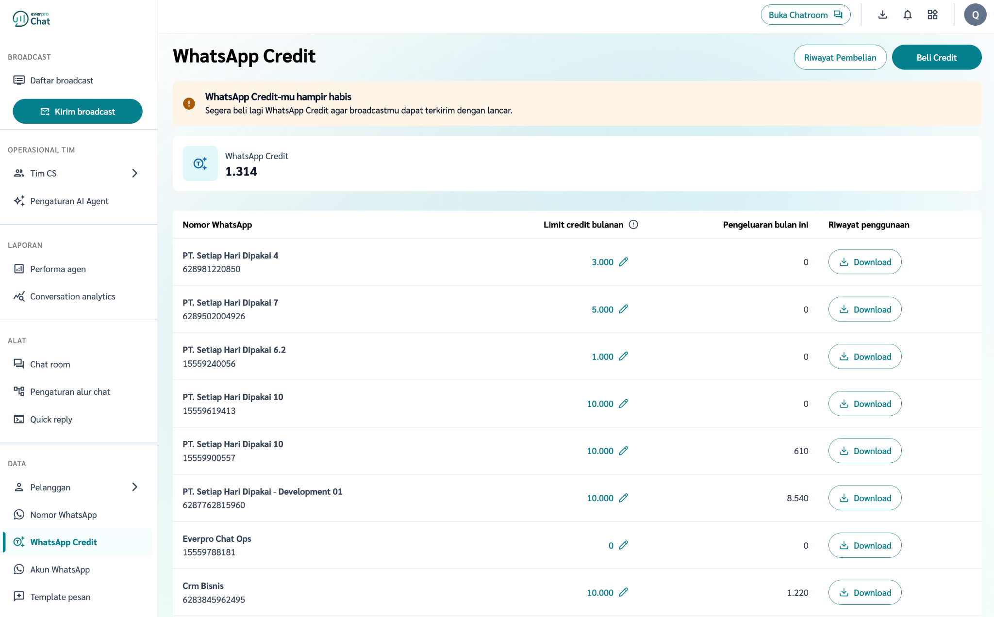
4 | As an Owner/Supervisor, I want to see | AC1 [Chatroom] Ongoing session cost visibility  Given I am an agent/owner/supervisor in an active chatroom conversation  When the conversation has one or more chargeable messages sent in the current session  Then I can see the running cost incurred for that session displayed in the chatroom  And the displayed cost updates in real time as new chargeable messages are sent  AC2 [Chatroom] Option to set a flat, non-segmented session limit  Given I am an Owner/Supervisor  When I access the session limit setting directly from the chatroom (quick-accessible, since this phase has no customer segmentation yet)  Then I can set a single flat per-session spend limit that applies generically to all conversations  And this limit is not customer-specific and does not depend on any label or segment  AC3 [Chatroom] Block further chargeable messages when limit is reached  Given a conversation's session cost has reached the configured flat limit  Then the conversation is flagged as limit-reached in the chatroom  And no further chargeable message can be sent in that conversation until the limit is increased  AC4 [Chatroom] Manual limit top-up by any agent  Given a conversation is flagged as limit-reached  When any agent — not restricted to Owner/Supervisor — opens that conversation  Then they see an option to add additional limit via a dropdown with preset amounts: Rp2.000, Rp5.000, or Rp10.000  When they select an amount and confirm  Then the session limit is increased by the selected amount, and the conversation is no longer blocked from sending chargeable messages  And the action is logged with the agent's identity, timestamp, and amount added

Known Issues, Limitations, and Workarounds
List down known issues, limitations and workaround of the product

Issues | Workaround

Question and Decision
List down all question arises during the process which needed decision or clarification to be made

Question | Answered | Decision
 | Yes/No | Explain the decision, put links to MoM if any, put Date if possible

Appendix
Additional documents related

